ID: 22424317
Question 1
Description
The crabs’ dataset is a data frame with 200 rows and 8 columns. Out of the 8 columns, 5 describe the morphological measurements on 50 crabs of two color forms and both sexes of the species Leptograpsus variegatus collected at Fremantle, W. Australia. These five variables have numerical values whiles index variable is an integer. Species and Sex are factors with 2 levels each.

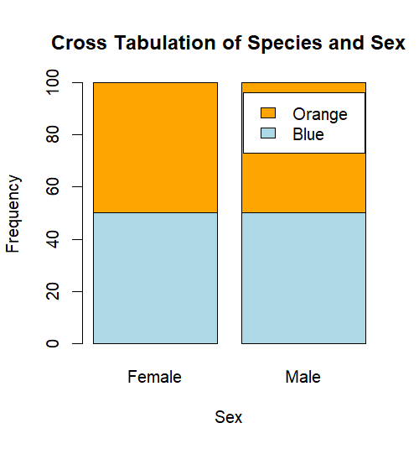
Comment
The dataset is balanced across all four groups because they all have the same number of observations. From the stacked bar chart, each group is evenly partitioned indicating confirming that the data is balanced across all four groups.

Question 2
From the boxplot below, the body depth by sex shows that Males have average body depth slightly higher than Females. There was higher variability within the Males compared with the Females. However, the difference in average body depth was higher between Blue species and Orange species. Orange species showed a higher average body depth compared with Blue species. There was higher variability within the orange species compared with the Blue species. There are no outliers among all four groups.
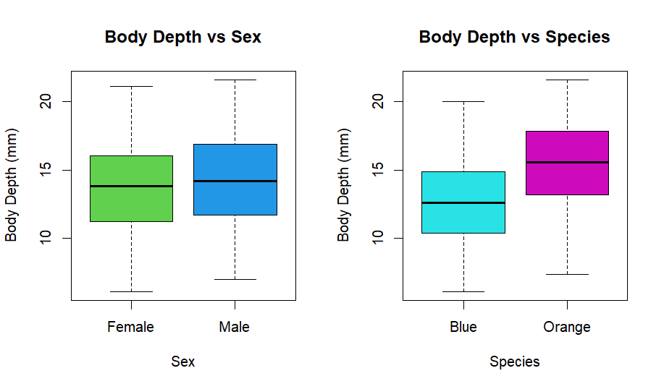
Question 3
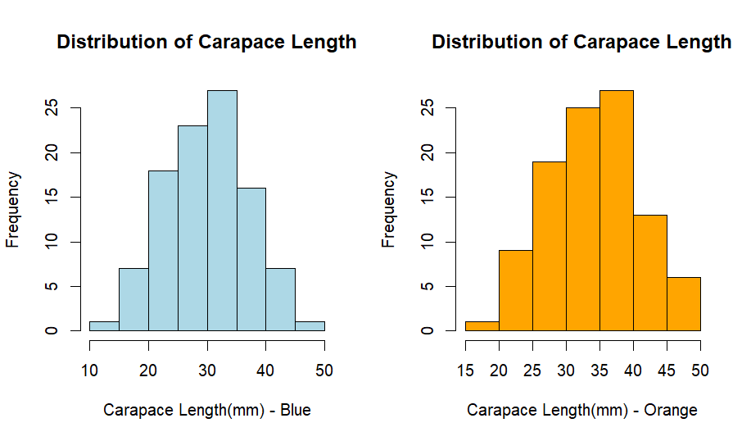
Comments
The above histograms show the distribution of carapace length in Blue and Orange species of the crab. In the both species, the distributions and fairly symmetric and unimodal. Also, both distributions are platykurtic, having light tails.

Question 5
The scatterplot matrix below shows the strength and direction of relationships between the 5 measurements from the crabs’ dataset. The relationships between all five measurements are positively correlated. However, the strength of relationships vary across the matrix with carapace length and carapace with have the comparatively the strongest relations whiles rear with and body depth has the least strength.
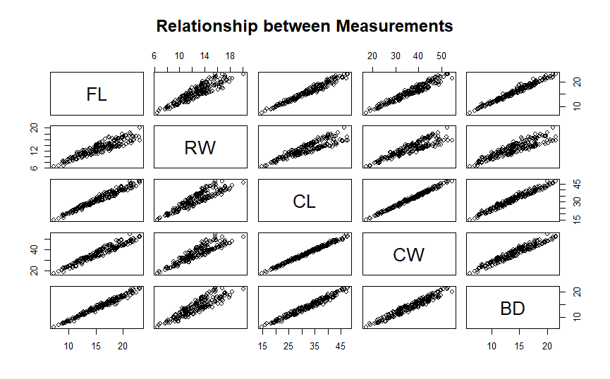
Question 4
Comments
From the computed means by sex, orange species showed the greatest species difference by species. On the other hand, Female showed least variation by sex.

Question 6
Integrated Statistical Report
The crab dataset comprises of 5 morphological measurements on 50 crabs of two color forms and both sexes of the crab, Leptograpsus variegatus collected at Fremantle, W. Australia. The dataset has 200 observations or rows and 8 variables or columns. Out of the 8, variables species and sex are factors of two levels whiles index is an identifier. The remaining 5 are continuous numerical variables.
The number of observations of all four group is 50 making the data balanced for comparison of means and variances between groups without weighting. Body depth distributions using boxplot showed variability between groups. It also showed that the median of body depth in Males were slightly higher than that of Females. On the other hand, there was greater variability in orange species compare with blue species. Also, the orange species showed higher median compare with Blue species.
The distributions of using the carapace length by species show that both blue and orange species are symmetric and unimodal. Also, both distributions are platykurtic, having light tails. Lastly, the computed means by sex, orange species showed the greatest species difference by species. On the other hand, Female showed least variation by sex.

